Ccna project
Networking Fundamentals and Practical Applications

Table of Contents
4- VLAN, show commands 2
5-etherchannel 2
6-STP ( spanning tree protocol) 2
7- HSRP (hot standby routing protocol) 3
8-DHCP 3
9-DHCP helper 6
10-port-security 8
11-ospf(open shortest path first) 9

4- VLAN, show commands

- Assigning gateway for VLANS
- And how to make VLANs see each other
  - We will use multilayer switch to act as a getway via Technique called (inter vlan routing ) نقل من شبكه لشبكه بين الفي لا نات
- Making sure that trunking is set to static instead of auto to avoid problems
  - Switchport trunk encapsulation dot1q
- For troubleshooting use
  - Do show ip route to show the routing table
  - Do show ip interface brief to show status of the interfaces

5-etherchannel

- We make 2 cable between 2 switches(multilayer) acts as if one cable using etherchannel(link aggregation). In the next lesson, we will initialize or make 2 switches act like one switch using the HSRP protocol
Hint: the orange color is because of the spanning tree protocol

- After doing EtherChannel, a new port will be created called port-channel one
- For troubleshooting or to make sure that ur work is done correctly, use this command: do show ether summary

6-STP ( spanning tree protocol)

- Is a protocol responsible for control l2 loop ( بروتوكول خاص بالسويتشات
- We‘ll use the rapid spanning tree command like this: in configuration mode => spanning-tree mode rapid-pvst
- For troubleshooting, use this command to make sure that spanning tree is fine: do show spanning- tree
Hint: in most cases, we make the Layer 2 area, in this case, I means multi layer switch, to be root (one of them would act like a bridge)

7- HSRP (hot standby routing protocol)

- We need to make a backup for a specific gateway
- The pc automatically will shift from this gateway to another gateway directly in case one the the specific routers or multilayer switches fails (getway)
- Doing virtual ip , vitual router; refer to 2 multilayer
Hint => use this command: Do show ip interface brief
Hint => do show vlan brief
Standby = local means I act as a standby

8-DHCP
- We will insert 2 servers: one acts as active and another for backup in case of failure of the first one. That’s good in a production environment.
- Bring the server and install DHCP on it will offer services like DNS, HTTP for web, and finally DHCP
- The Backup server is preferred to be in another network ID.
- The is the server dhcp how it would distribute the IP across the network (lan) If you come form vlan 10 , will give you from the range that belong to vlan 10 . if you come from VLAN 20, I'll give you from the range that belongs to VLAN 20,…etc
- 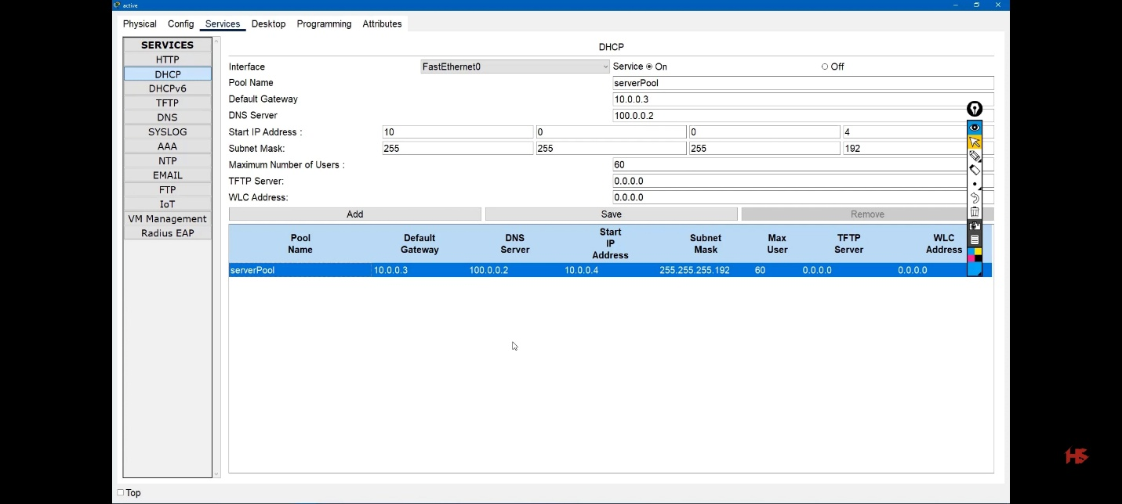

This is the GUI of the server connected to the multilayer switch, and VLAN 100 was created on that multilayer switch for the server under interface f0/2 (multilayer switch). This is the configuration, for example.
Pool name: server pool (any name Hr)
Default Gateway: 10.0.0.3. لي هوا أي حد جايلك من شبكه عشرات تبع في لان 10 يعني SVI
DNS server: 100.0.0.2. ip بتاع السيرفر ذات نفسه عشان لو جد سأله علي موقع معين يسال السيرفر ذات نفسه
Start ip address : 10.0.0.4 with subnet mask 255.255.255.192
Then click Save for the first pool.
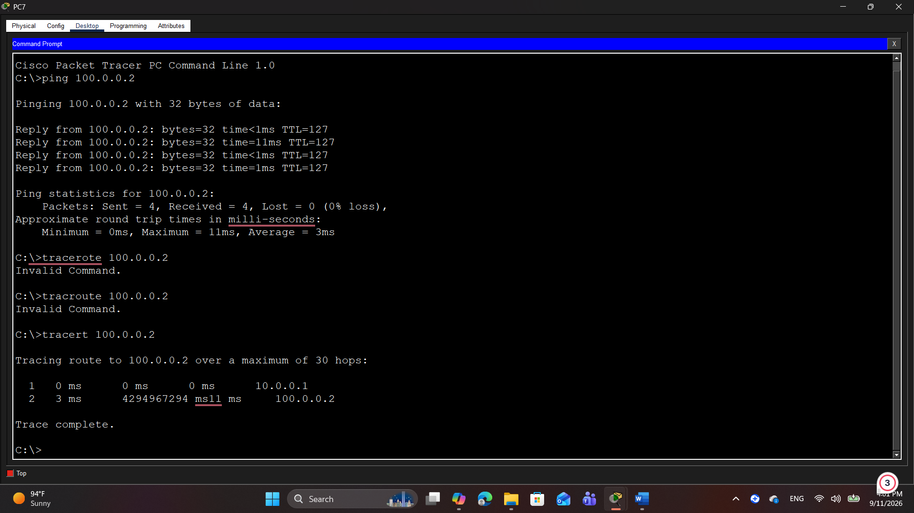
- We can make as well 2 servers(dhcp) active , active , and doing load balancing between them instead of one is active and another is backup.

9-DHCP helper
Note: first message from pc (discover) is a broadcast message. According to the topology, the multilayer switch will not allow broadcasts to pass, so what should we do?
Int vlan 10
Ip helper-address 100.0.0.2
Will turn the message to unicast instead of broadcast for a specific VLAN (10)
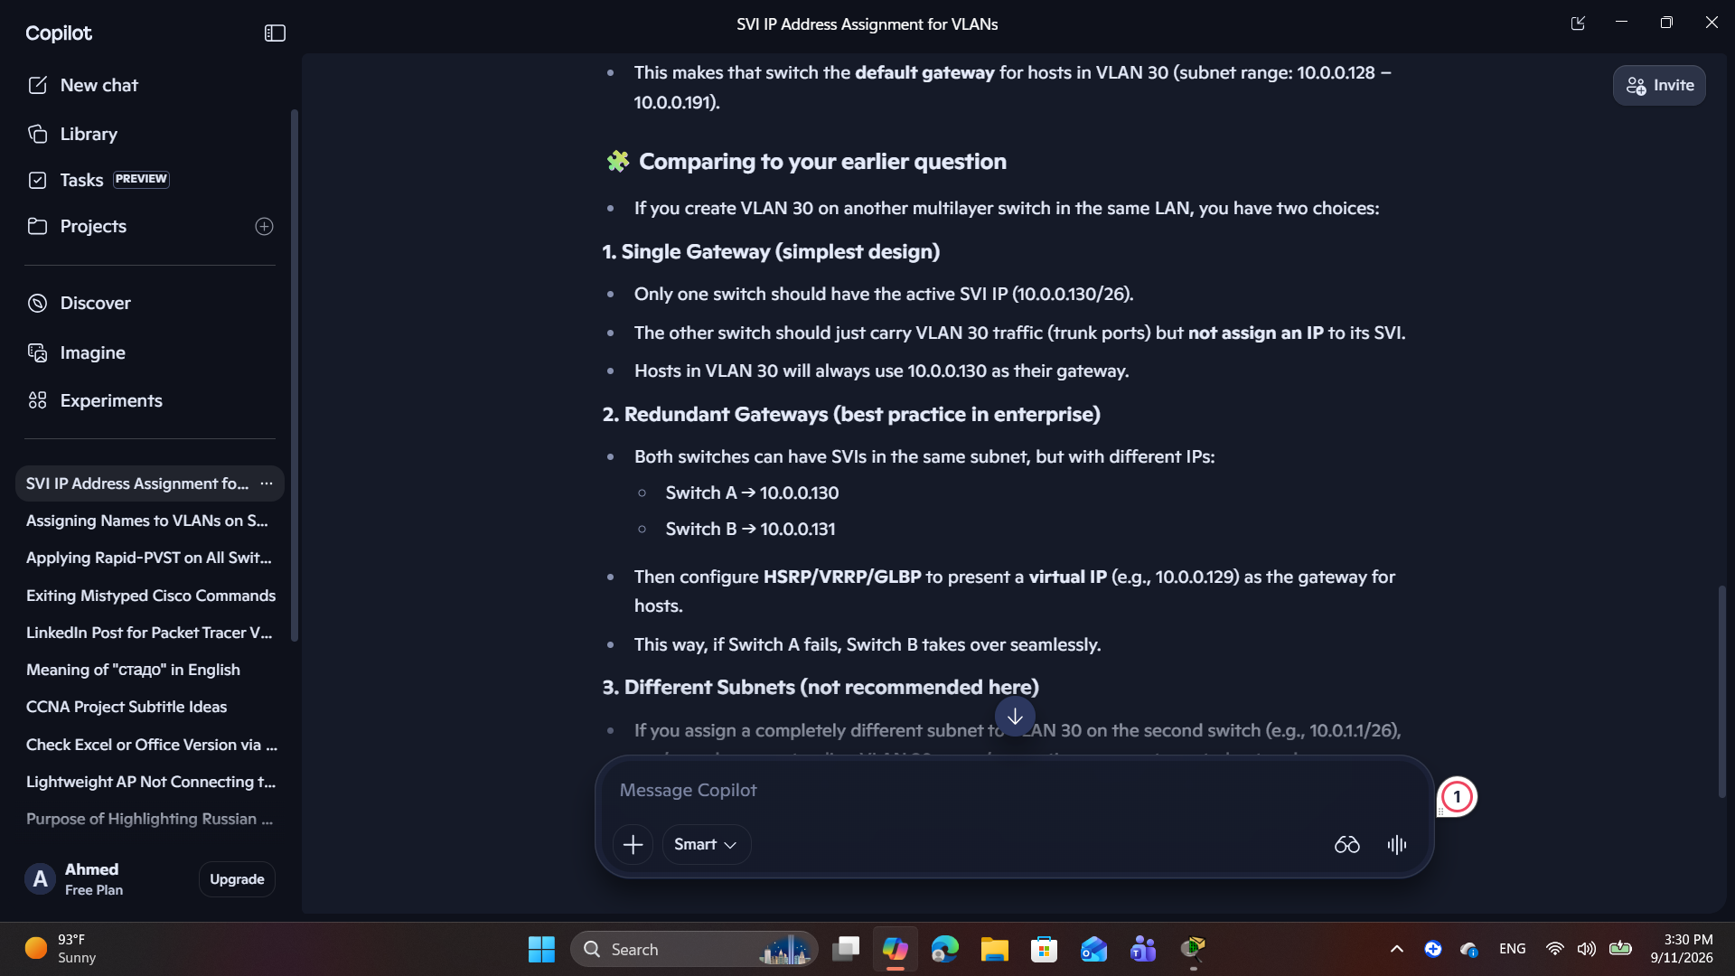
Notes: Routing is the only way to transfer traffic properly from one VLAN to a different VLAN لازم الخاصيه بتاعة الراوتر تكون متفعله

Use this command ip route, then
Do write for saving

- 3:33 minutes. doing troubleshooting
  - Make sure the server IP is correct, and ping the correct on it’s getway (multilayer switch)
  - We will make swtich 0 as an active swtich for vlan 10 to pc in vlan 10 connect to server .
Priority in HSRP
- By default, all HSRP routers have priority 100.
- The higher priority wins — not lower. So if one switch is set to 150, and the other remains at 100, the one with 150 becomes the active router for VLAN 10.
- That’s why your instructor increased the value: raising priority above 100 ensures this switch is preferred as the active gateway.
The role of standby 10 preempt
- Without preempt, once a switch becomes active, it stays active until it fails — even if a higher-priority switch later comes online.
- With preempt enabled, if the higher-priority switch (150) recovers, it will take back the active role from the lower-priority switch (100).
- This ensures that your “preferred” switch (the one with higher priority) always serves as the active gateway when available.

- Set dhcp , dns (name like dhcp and ip like 100.0.0.2)
- From pc7 do this command to make sure dns is fine : ping dhcp

10-port-security

- We want to secure the physical port that connects, for example, the end device, by making sure that this device is the only device that can connect to its own port in that switch (access), not another pc.
- So when another pc (another MAC address) wants to take crazy action and connect itself via cable to the port that does not belong to it, the port will fail in error disabled and reject it . مش انتا الجهاز لي كنت متوصل عليا
- الاجهزه تلتزم بالبورتات بتاعتها والاجزه الأخرى تلتزم ببورتاتها محدش يجي علي بورتات حد
- ي بورت كذا الماك ده هوا المسموح تستقبلي منه داتا
Dynamic port (appeared in the messages) 7:20 minutes
means we don’t know whether this port is access (connected to pc ) or trunk connected to a switch.
- Interface fa0/1
- Switchport port security
- Switchport mode access
- وضع الشروط بقا
- Switchport port -security maximum 1
- Switchport port-security mac-address sticky
- Switchport port-security violation shutdown
For troubleshooting
Do show port-security
Do show run . (focus on mac)
Do show interface status (useful)

11-ospf(open shortest path first)
Port 89
- We will bring a switch act as a connection to link the branch , data center , and the internet .
- 2 router make you go for internet
- And third multi layer switch added to take any traffic from and to our datacentre (servers)
- Ip routing
- Do show ip route

- int g0/1
- no switchport
- ip address 10.11.11.1 255.255.255.0 (become routed interface)

- do show ip interface brief
- do show ip route

- Router ospf 1
Define router id ده رساله جهاز كذا او راوتر كذا لما يبلغني بشبكته او يديني ابديت

- router-id 1.1.1.1

network 10.0.0.0 255.255.255.192 area 0
- Network 0.0.0.0 255.255.255.255 area 0

كلم الناس من خلال شبكه رقم كذا برسايل ال OSPF
الشبكات لي انت تعرفها ده ابعتها بصيغه ال
OSPF
وابعتها لكل الناس

- Any network wirte as follow 0.0.0.0
- Any subnetmusk 0.0.0.0 but we write the wildcard you must write as follow 255.255.255.255

